**Name :** Divyang Bagla

**Panel :** C

**Roll No. :** PC 33

**Subject:** BDA Practical Exam

**Problem Statement**



**Solution:-**

**HTML FILE:-**

<!doctype html>

<html>

<head>

    <style>

        .bar {

            fill: #DC143C;

        }

        .bar:hover{

            fill: #FA8072;

            transition: all .2s;

        }

    </style>

    <script src="https://d3js.org/d3.v4.min.js"></script>

<body>

<svg width="1200" height="500"></svg>

<script>

    //create SVG and define scales.

    var svg = d3.select("svg"),

    margin = 200,

        width = svg.attr("width") - margin,

        height = svg.attr("height") - margin

    svg.append("text")

       .attr("transform", "translate(100,0)")

       .attr("x", 50)

       .attr("y", 50)

       .attr("font-size", "30px")

       .text("Students over 11 Years")

    var xScale = d3.scaleBand().range([0, width]).padding(0.4),

        yScale = d3.scaleLinear().range([height, 0]);

    var g = svg.append("g")

               .attr("transform", "translate(" + 100 + "," + 100 + ")");

    d3.csv("data.csv", function(error, data) {

        if (error) {

            throw error;

        }

        xScale.domain(data.map(function(d) { return d.year; }));

        yScale.domain([0, d3.max(data, function(d) { return d.value; })]);

        g.append("g")

         .attr("transform", "translate(0," + height + ")")

         .call(d3.axisBottom(xScale))

         .append("text")

         .attr("y", height - 250)

         .attr("x", width - 100)

         .attr("text-anchor", "end")

         .attr("stroke", "black")

         .text("Years");

        g.append("g")

         .call(d3.axisLeft(yScale).tickFormat(function(d){

             return d;

         })

         .ticks(10))

         .append("text")

         .attr("transform", "rotate(-90)")

         .attr("y", 6)

         .attr("dy", "-5.1em")

         .attr("text-anchor", "end")

         .attr("stroke", "black")

         .text("No. of students");

        g.selectAll(".bar")

         .data(data)

         .enter().append("rect")

         .attr("class", "bar")

         .attr("x", function(d) { return xScale(d.year); })

         .attr("y", function(d) { return yScale(d.value); })

         .attr("width", xScale.bandwidth())

         .attr("height", function(d) { return height - yScale(d.value); });

    });

</script>

</body>

</html>

**Data Set Used :-**

year,value

2010, 506

2011, 499

2012, 514

2013, 621

2014, 710

2015, 654

2016, 553

2016, 602

2017, 512

2018, 531

2019, 620

2020, 351

**OUTPUTS :-**

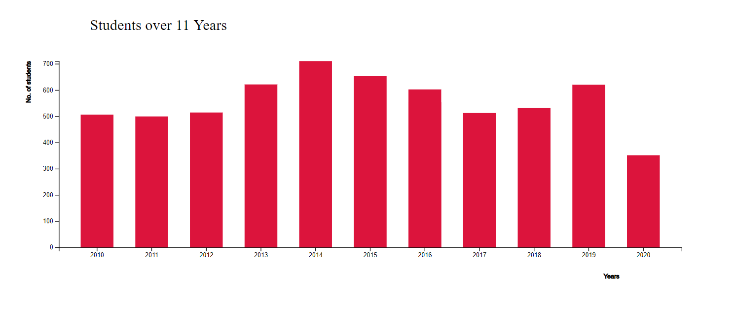

**On hover Color changes :-**

